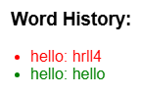 const checkButton = document.getElementById("checkButton"); checkButton.addEventListener("click", checkWord);

 const typingInput = document.getElementById("typingInput"); const typed = typingInput.value.trim().toLowerCase();

const currentWord = wordList[currentIndex].toLowerCase();

const isCorrect = typed === currentWord;